MONACO PAVILION
AT EXPO 2020 DUBAI

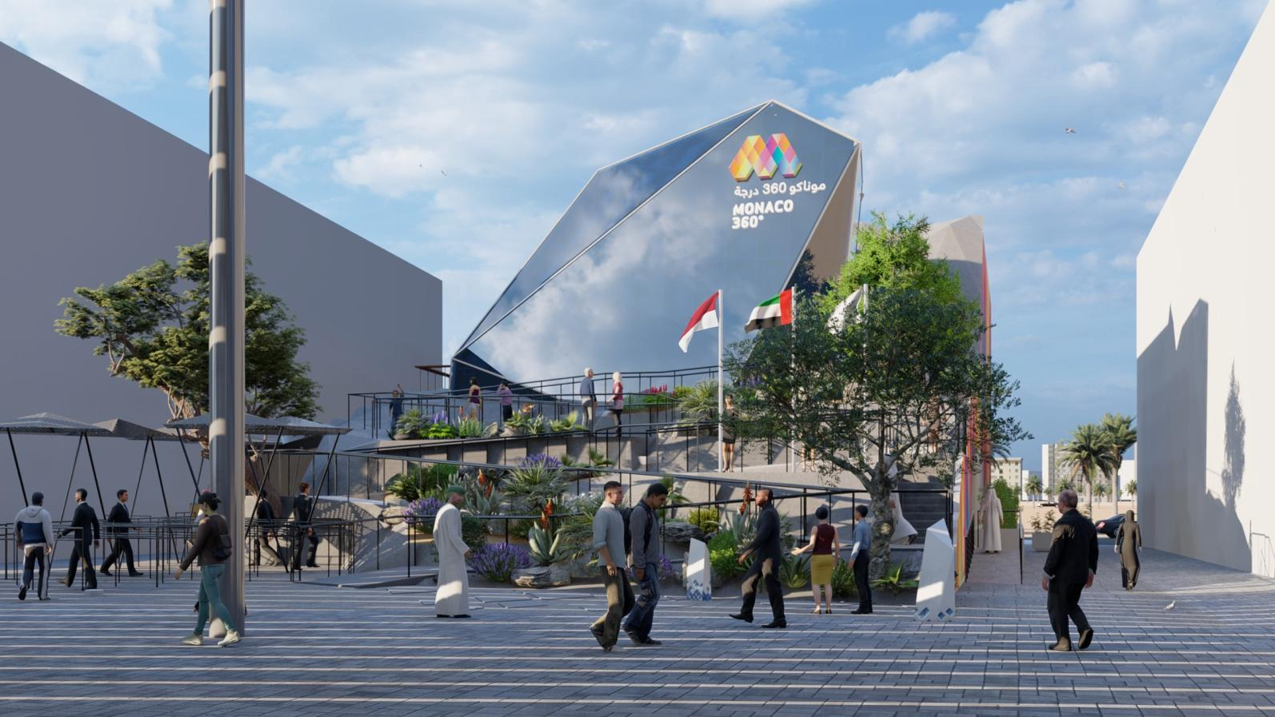

CONCEPT / IDEA

In line with Expo 2020 Dubai’s theme of ‘Connecting Minds, Creating the Future’, the architecture of Monaco Pavilion surprises and fascinates. It is inspired by a kaleidoscope that incorporates the "Rock" of Monaco and reflects the many facets of the Principality: its characteristics, its professions, its actions, its multiple perspectives, its diversity ... and the incredible amount of activities, often underrated or even unknown opportunities offered by the country. With this in mind, we have chosen the Pavilion to be located in Expo 2020’s Opportunity Thematic District.

The main and polygonal shape of the Pavilion with the prominent use of photovoltaic panels evokes the eco-friendly governance of Monaco and its many actions to protect the environment, under the will of His Serene Highness Prince Albert II.

We are committed to designing a Pavilion with a balance of production/consumption of electricity the closest to zero. Our second priority is to build a Pavilion that aims for the majority of its used materials to be recycled.

With the expertise of the Monegasque Company of Electricity and Gas (SMEG) teams, we will produce energy by using photovoltaic equipment from the end of 2019 until September 2021, to balance out the electricity we will consume during the six months of Expo 2020. As night falls, the Pavilion will display its energy production and knowledge by redistributing the sunlight it has stored during the day throughout the Pavilion.

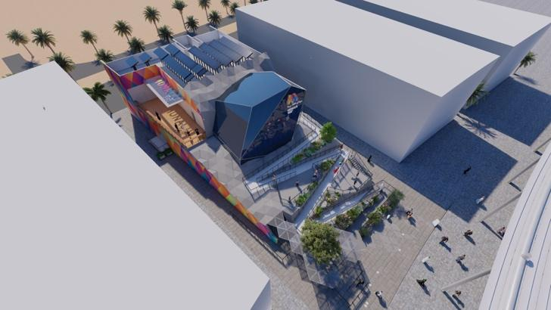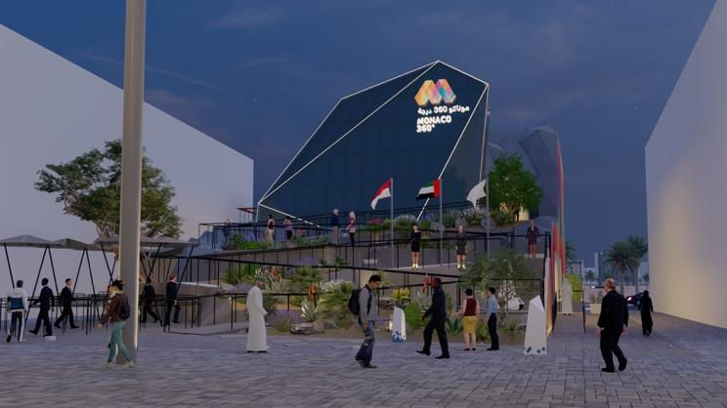

DESIGN

The Pavilion is spread over different levels, just like the mazy streets of Monaco that are full of surprises. It is an invitation to discover, observe and interact with an environment of cultural resources, research and know-how.

The Pavilion consists of an exhibition area, a souvenir shop and a restaurant on the ground floor.

Visitors will enjoy two main exhibition worlds. The first, named "the Garden of Opportunities" showcases projects and high-quality pioneering work, made in Monaco and internationally. It will look like a kaleidoscopic fantasy garden that comes out of one’s imagination. All facilities of the Pavilion are interactive, with diverse interfaces that offer multiple forms of engagement to interested and curious visitors.

The second area is a show that reveals the "identity" of Monaco. A 360-degree immersion that takes the visitor into the history, culture and values ​​of Monaco and its citizens.

On the first floor, a private and flexible space inside the "Rock" enables the organization of events, conferences and meetings to accentuate the participation of the Principality.

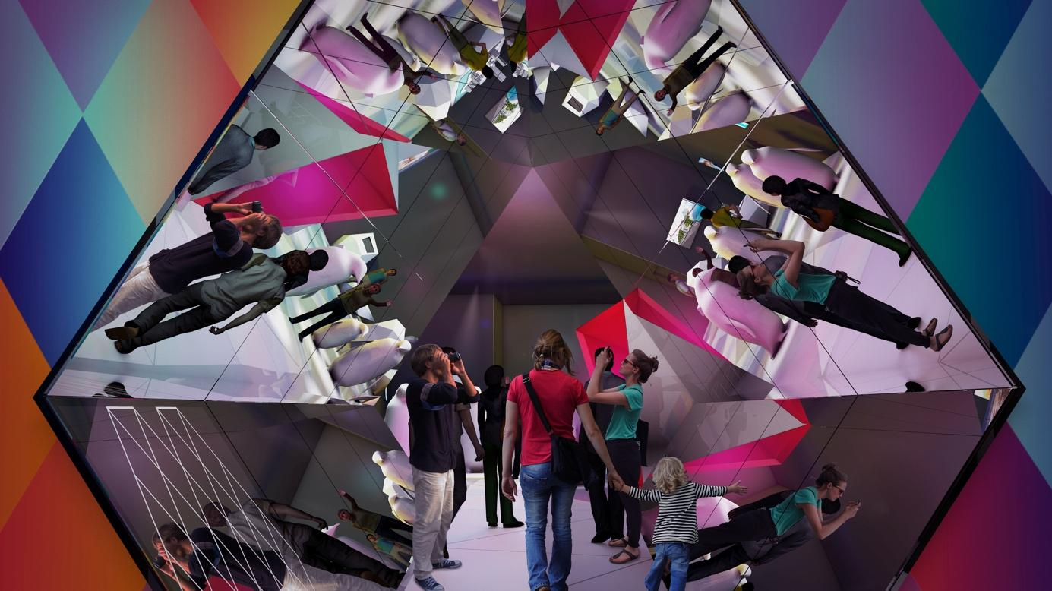

Light

Lighting is a key element used in the design of the exhibition environment.
Inspired by the spectrum of warm colors of the French Riviera, the luminous atmosphere of the "Garden of Opportunities" will change throughout the day and plunge the Pavilion into a Mediterranean landscape.

LOGO / VISUAL IDENTITY

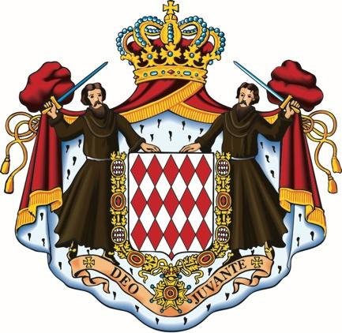
From the diamond of the Grimaldi coat of arms to the Pavilion logo.

The big "M" represents Monaco powerfully and clearly. In the imposing symbol, we see the image of a kaleidoscope or even a rock – the “Rock”. The warm color gradient is reminiscent of the unique sunsets of the French Riviera. A spectrum of colors and modernity that leads visitors through the many facets of Monaco, from elegance to dynamism, from science to discovery. The watermark lines reflect the conceptual idea of ​​"connections".
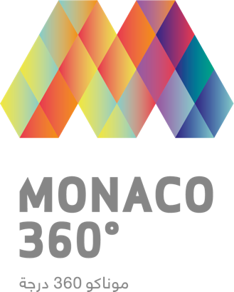
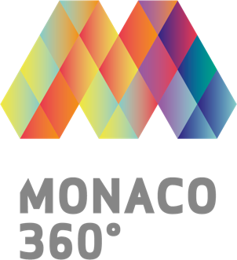
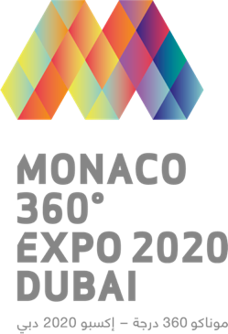

VISITOR EXPERIENCE / JOURNEY

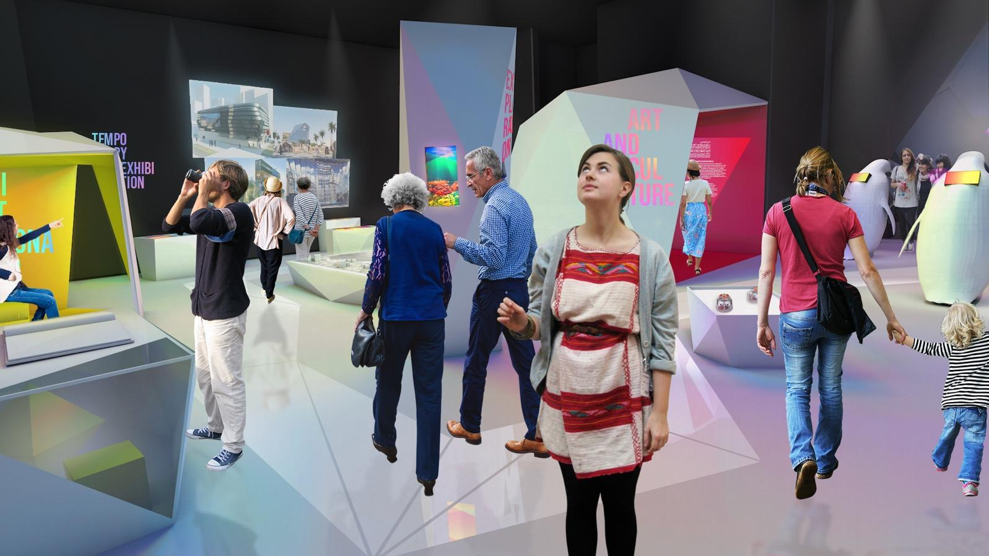

Right before entering the pavilion, the visitor will be immersed in the "History of Monaco" thanks to an iconographic frieze recounting the Grimaldi Dynasty.

As visitors enter the "The Garden of Opportunities" they will experience signature smells of the French Riviera such as pine, the sea and the sun, as they journey through different exhibition stations in a bright and warm atmosphere to discover:
- Arts and Culture
- Science, Polar Research and Medical Bio
- Protection of Biodiversity and Oceans
- Innovation and Technology
- Explorations and the International

The visit of the "Garden of Opportunities" will end with a unique experience in the Kaleidoscope, where visitors will discover the identity of “Monaco 360°, a world of opportunities”, through the arts and culture, science and sport, tourism and hospitality, history and exploration, extensions of its territory, gastronomy and tradition.

Next to the Pavilion’s exit, a souvenir shop will offer a varied range of items from the Principality of Monaco before giving way to a restaurant and takeaway area that will offer people an opportunity to experience the taste of Mediterranean and Monegasque cuisine.

Outside the pavilion, visitors will be able to rest on the gentle slope named "Chemin de la Porte Neuve" full of typical trees and flowers design by the urban development of Monaco, which leads to the “Rock” and the first floor. They will also be able to enjoy artistic performances that will take place throughout the Expo.

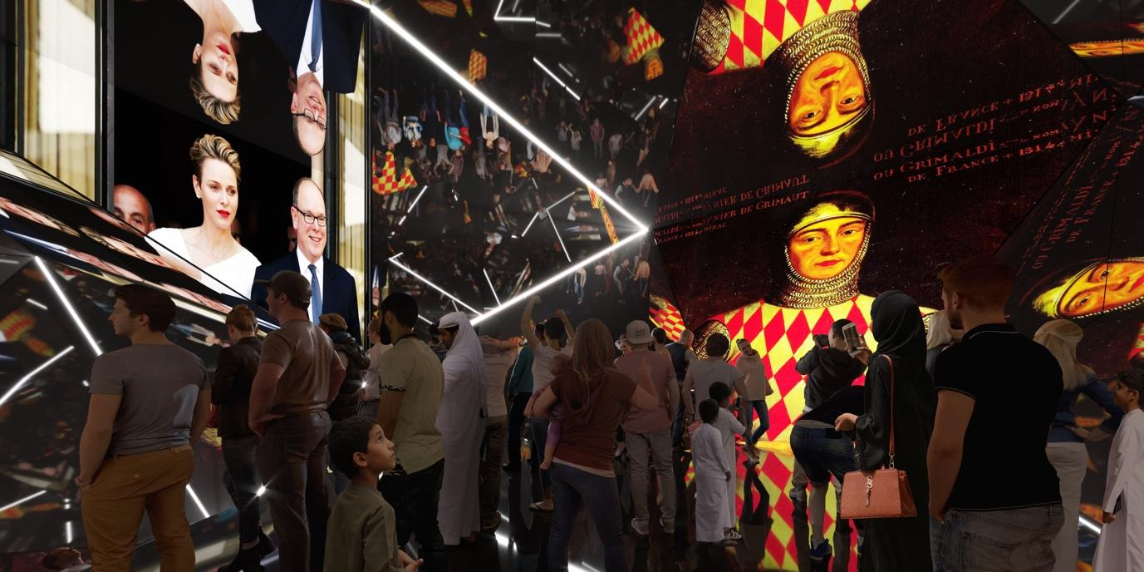
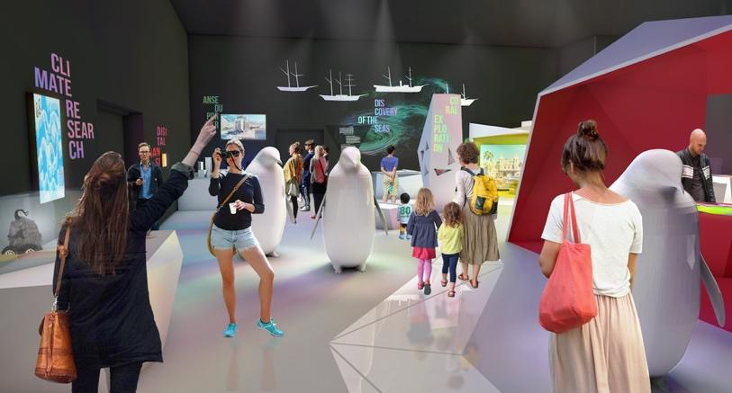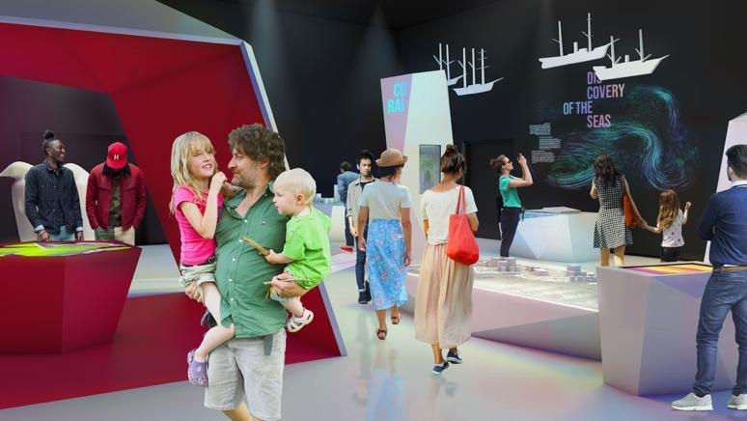
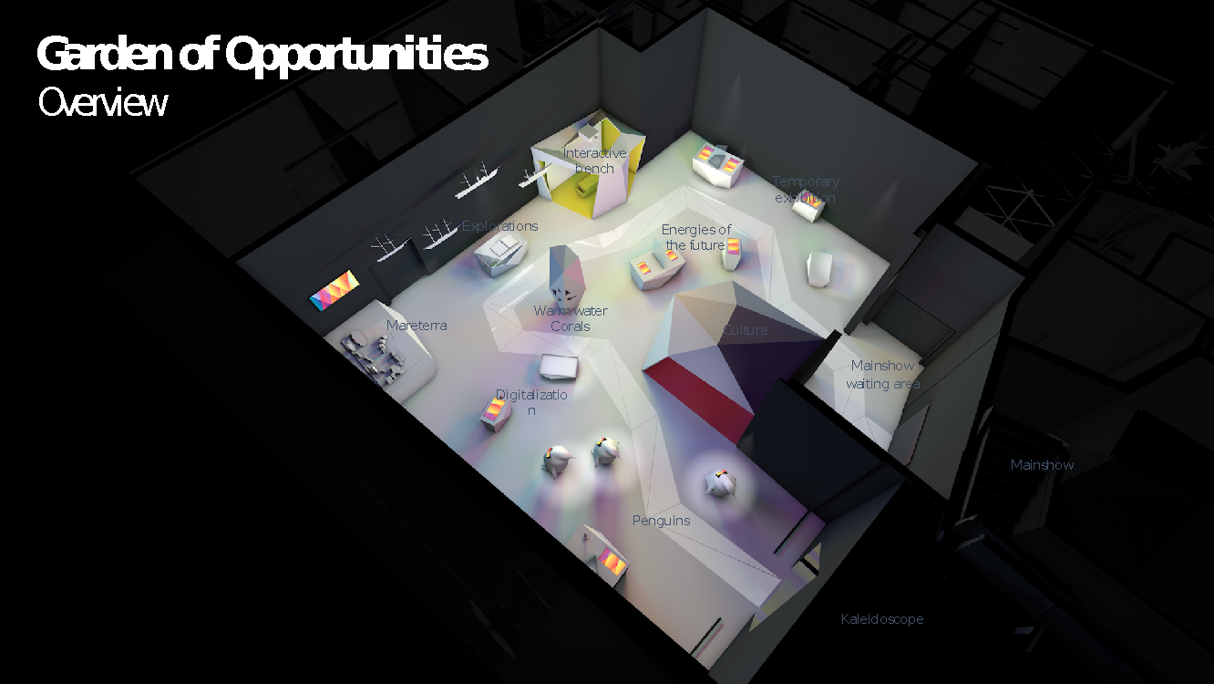
BEHIND THE PAVILION

Monaco Inter Expo
Monaco Inter Expo is a State-owned Monegasque Company (SAM). It is placed under the supervision of the Department of External Relations and Cooperation. It is responsible for the Principality of Monaco’s participation (conception, realization and operation) in Universal and Specialized Exhibitions under the aegis of the International Exhibitions Bureau.

AODA
Olivier Deverini is the founder of the AODA architecture firm, which was formed in Monaco in 2008. The firm works on a wide variety of projects, all of which have the same objective: the environment and sustainability of construction at all stages of works, from the home to the district, to the town.

facts and fiction
facts and fiction is responsible for the concept, design, construction and maintenance of the Monaco pavilion. The agency specializes in exhibition design, scenography and storytelling and has designed museum exhibitions internationally. Already well known to the Expo world, facts and fiction has designed seven pavilions for countries and companies since 2000 – among others, the agency designed the scenography for the Monaco Pavilion in Milan 2015 and also has won the tender for the German Pavilion at Expo 2020.

OOS Studio
OOS is an owner-managed architectural practice in Zurich with around 20 employees. Its core competence lies in the consulting, design and planning of corporate architecture. OOS translates the values and positioning of its clients into space. The results are tailor-made environments for experience and work in the scales of urban planning, architecture and interior design

For further information: redaction@mie.mc
Monaco Inter Expo
16, rue Princesse Florestine
98 000 Monaco
+377.93.50.89.89

OFFICIAL PARTNERS OF THE PAVILION
